Final Classification Report

1. Data Split Summary
Subset | Count | Ratio
Training | 29358 | 70%
Validation | 6291 | 15%
Testing | 6291 | 15%

2. Best Model Selection
The best performing model, based on a custom weighted average of metrics (including per-class performance), is: Random Forest with a weighted score of 0.6687.
Weights used: {'Accuracy': 1.0, 'ROC-AUC': 1.5, 'Precision (AI)': 1.0, 'Recall (AI)': 1.0, 'F1-Score (AI)': 2.0, 'Precision (Human)': 1.0, 'Recall (Human)': 1.5, 'F1-Score (Human)': 1.0}

3. Model Metrics Summary (Sorted by Weighted Performance)
Model | Accuracy | ROC-AUC | Precision (AI) | Recall (AI) | F1-Score (AI) | Precision (Human) | Recall (Human) | F1-Score (Human) | Weighted_Score
Naive Bayes | 0.8617 | 0.6932 | 0.8619 | 0.9996 | 0.9257 | 0.6667 | 0.0046 | 0.0091 | 0.6297
Logistic Regression | 0.8609 | 0.7036 | 0.8625 | 0.9976 | 0.9251 | 0.4348 | 0.0115 | 0.0223 | 0.6101
Random Forest | 0.8034 | 0.7679 | 0.8947 | 0.8747 | 0.8846 | 0.3162 | 0.3601 | 0.3367 | 0.6687
SVM | 0.8614 | 0.4708 | 0.8614 | 1.0000 | 0.9255 | 0.0000 | 0.0000 | 0.0000 | 0.5280
XGBoost | 0.8614 | 0.6953 | 0.8615 | 0.9998 | 0.9255 | 0.5000 | 0.0011 | 0.0023 | 0.6121
Feedforward NN + BERT (768D) | 0.8617 | 0.7055 | 0.8619 | 0.9996 | 0.9257 | 0.6667 | 0.0046 | 0.0091 | 0.6316

4. Best Model Detailed Report
Metric | precision | recall | f1-score | support
AI | 0.8947 | 0.8747 | 0.8846 | 5419.0000
Human | 0.3162 | 0.3601 | 0.3367 | 872.0000
accuracy | 0.8034 | 0.8034 | 0.8034 | 0.8034
macro avg | 0.6054 | 0.6174 | 0.6107 | 6291.0000
weighted avg | 0.8145 | 0.8034 | 0.8086 | 6291.0000

5. Performance Benchmark Plot (Full Metrics)
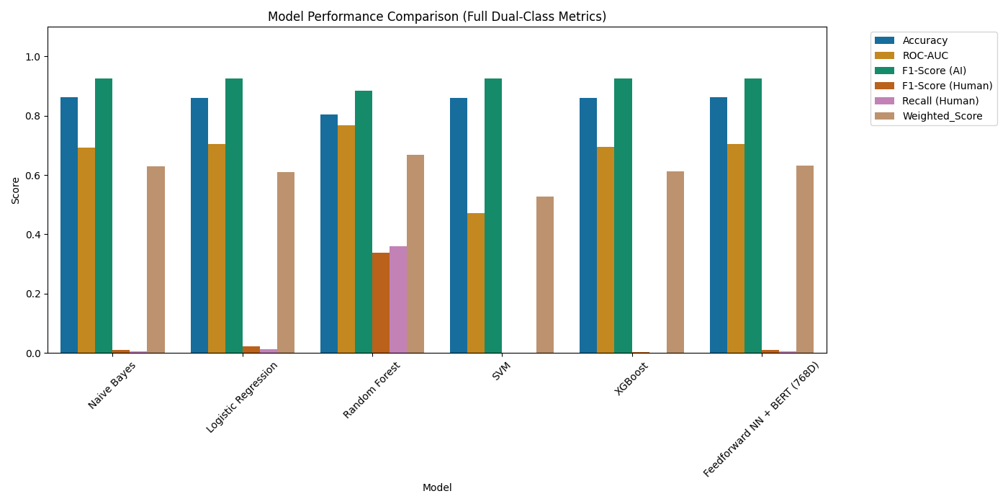

6. ROC Curves (All Models)
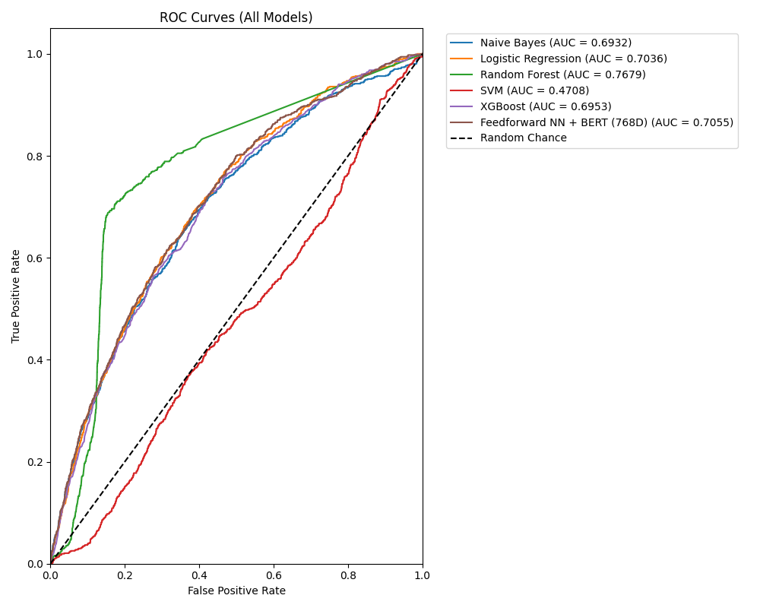

7. Model Analysis (Confusion Matrix + Error Confidence)

Model: Naive Bayes
Confusion Matrix:
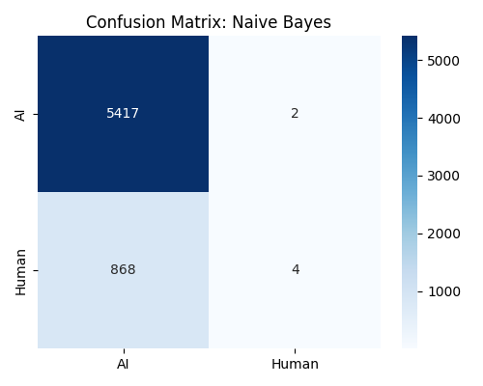
Error Confidence Analysis:
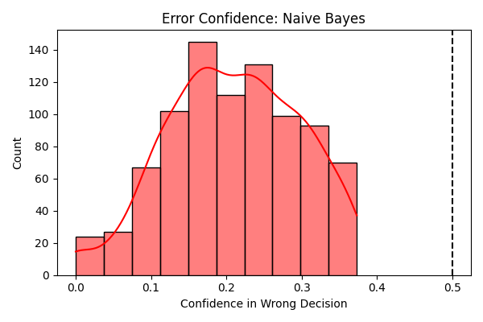

Model: Logistic Regression
Confusion Matrix:
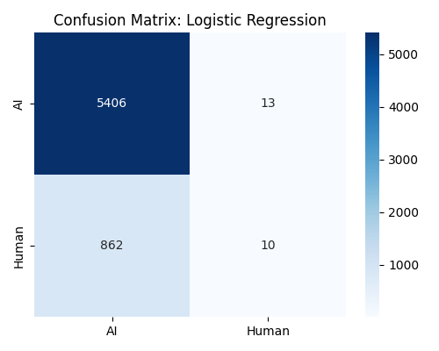
Error Confidence Analysis:
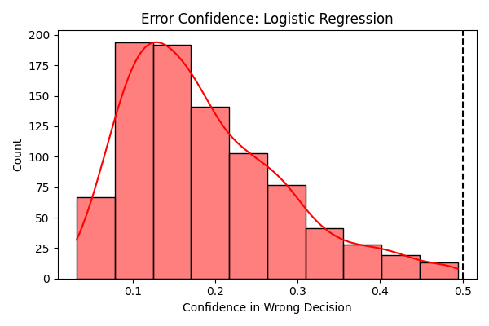

Model: Random Forest
Confusion Matrix:
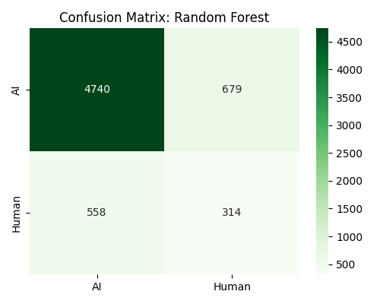
Error Confidence Analysis:
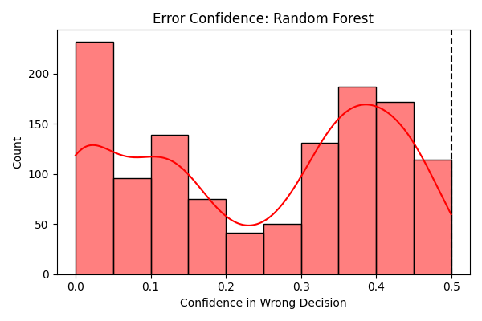

Model: SVM
Confusion Matrix:
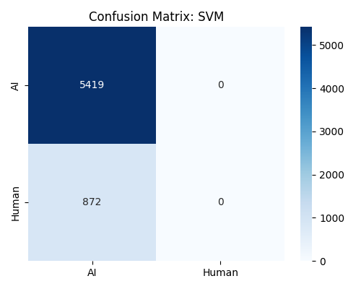
Error Confidence Analysis:
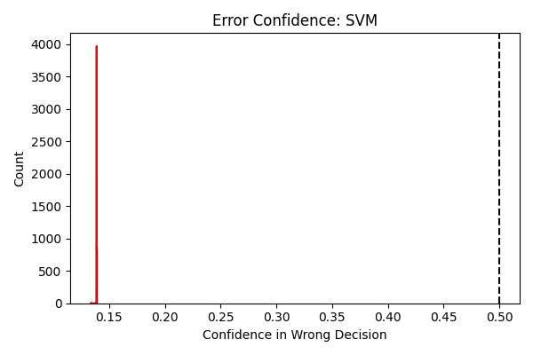

Model: XGBoost
Confusion Matrix:
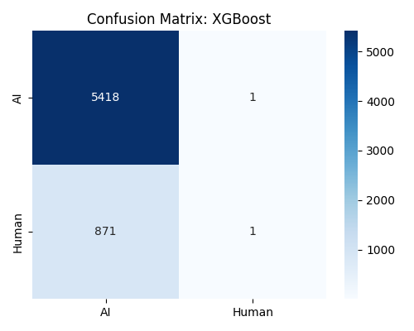
Error Confidence Analysis:
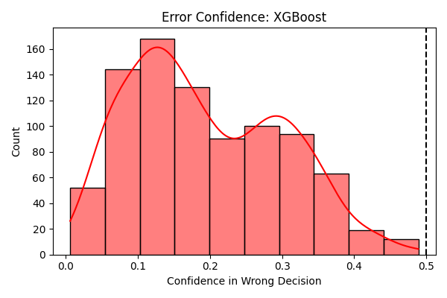

Model: Feedforward NN + BERT (768D)
Confusion Matrix:
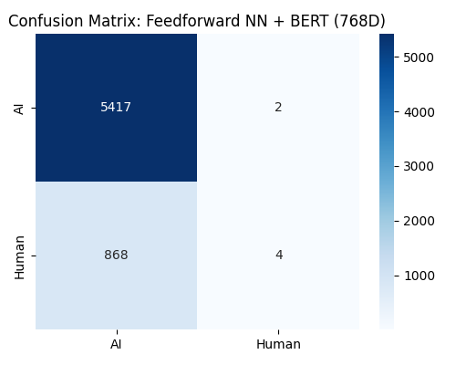
Error Confidence Analysis:
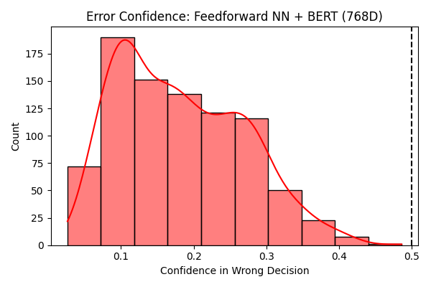

8. Feature Importance (Best Tree-Based Model)
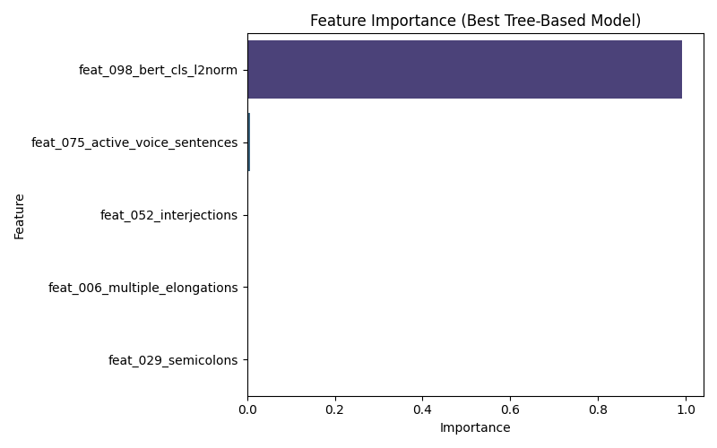

9. Neural Network Training History
